ALGORITMO

1 function predictAge(age1,age2,age3,age4,age5,age6,age7,age8){

2 var ages = [age1,age2,age3,age4,age5,age6,age7,age8];

3 var counter=0;

4 var sum=0;

5 for(var i=0;i<ages.length;i++){

6  sum+= Math.pow(ages[i],2);

  }

7 var sqrtroot = Math.sqrt(sum)/2;

8 return Math.floor(sqrtroot);

}

CALCULO

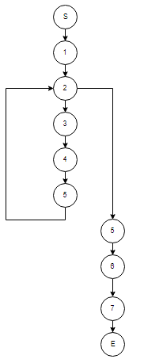

M= E-N+2

M= 10 – 10 +2 = 2